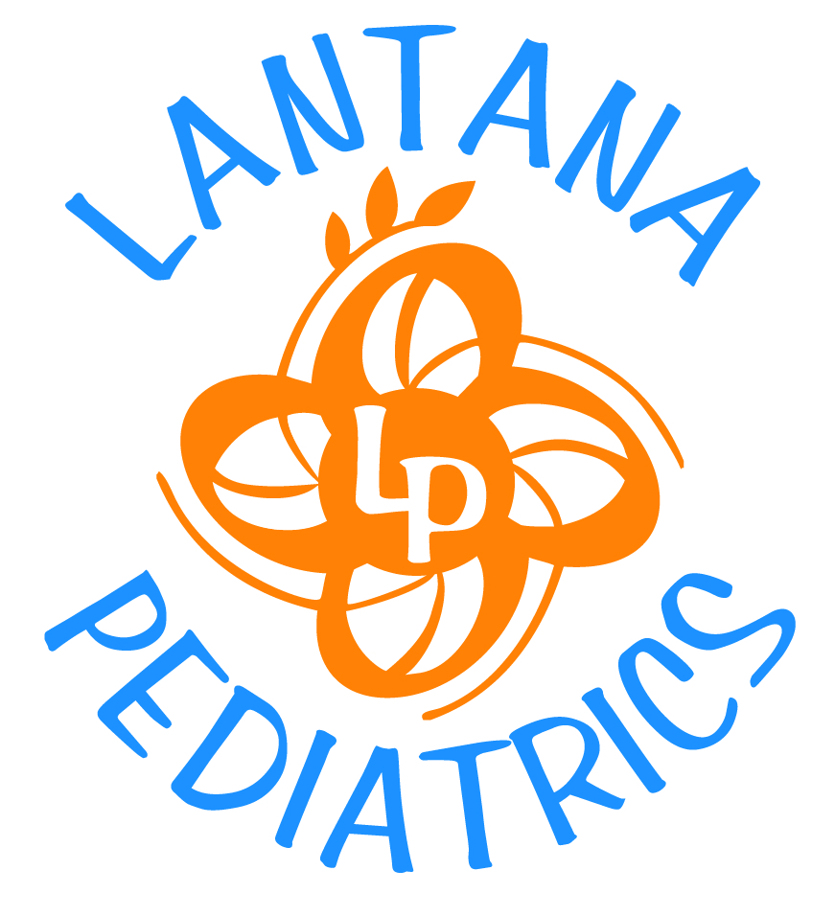
BOOKS/REFERENCES
GENERAL
- Dr. Spock's Baby and Child Care: 8th Edition (Paperback) by Benjamin Spock (Author), Robert Needlman (Editor)
- Taking Care of Your Child: A Parent's Illustrated Guide to Complete Medical Care by James F. Fries, Robert H. Pantell, Donald M. Vickery
- Caring for Your Baby and Young Child: Birth to Age 5, 4th edition. American Academy of Pediatrics; Steven P. Shelov, MD, MS, FAAP, Editor in Chief, and Robert E. Hannemann, MD, FAAP
- Caring for Your School-Age Child: Ages 5 to 12 American Academy of Pediatrics; Edward L. Schor, MD, FAAP, Editor in Chief

CHILD DEVELOPMENT AND TEMPERAMENT
- The Wonder Years, American Academy of Pediatrics; Edited by Tanya Remer Altmann, MD, FAAP
- The Difficult Child: Expanded and Revised Edition by Stanley Turecki and Leslie Tonner
- Raising Your Spirited Child: A Guide for Parents Whose Child Is More Intense, Sensitive, Perceptive, Persistent, And Energetic by Mary Sheedy Kurcinka
- Toddlers and Parents: A Declaration of Independence by T. Berry Brazelton

- Inf
INFANTS
- Infants and Mothers: Differences in Development by T. Berry Brazelton
- Touchpoint, by T. Berry Brazleton

CHILDREN
- Motivated Minds: Raising Children to Love Learning by Deborah Stipek, Kathy Seal
- Pressured Parents, Stressed-out Kids: Dealing With Competition While Raising a Successful Child by Wendy S. Grolnick, Kathy Seal

DISCIPLINE and COMMUNICATION
- How to Talk So Kids Will Listen & Listen So Kids Will Talk by Elaine Mazlish, Adele Faber, Kimberly Ann Coe
- How to Talk So Teens Will Listen & Listen So Teens Will Talk by Elaine Mazlish, Adele Faber, Kimberly Ann Coe
- Drawing the Line: Ten Steps to Constructive Discipline--And Achieving a Great Relationship with Your Kids by Michael J. Weiss, Sheldon H. Wagner, and Susan Goldberg
- Discipline Without Shouting or Spanking: Practical Solutions to the Most Common Preschool Behavior Problems by Barbara C. Unell and Jerry L. Wyckoff. Parenting With Love and Logic by Foster Cline and Jim Fay (also see www.loveandlogic.com)
- Nutrition

NUTRITION
- How to Get Your Kid to Eat but Not Too Much by Ellyn Satter

- American Academy of Pediatrics Guide to Your Child's Nutrition by William H. MD PhD Dietz, Loraine M. Stern

- Mommy made-- and daddy too: home cooking for healthy baby and toddler by Martha Kimmel, David Kimmel, Suzanne Goldenson

SLEEP
- Healthy Sleep Habits, Happy Child, by Marc Weissbluth Sleeping Through the Night by Jodi Mindell
- Solve Your Child's Sleep Problems by Richard Ferber
- Good Night Sleep Tight: The Sleep Lady’s Gentle Guide to Helping Your Child Go to Sleep, Stay Asleep, and Wake Up Happy (Paperback) by Kim West and Joanne Kenen

SIBLING RIVALRY

- Understanding Sibling Rivalry: The Brazelton Way by Joshua D. Sparrow, T. Berry Brazelton
- Siblings Without Rivalry: How to Help Your Children Live Together So You Can Live Too by Adele Faber, Elaine Mazlish

PHYSICAL AND SEXUAL DEVELOPMENT
- Care & Keeping of You: The Body Book for Girls by Valorie Schaefer, Norm Bendell

ASTHMA
- AAP Guide to Your Child's Allergies and Asthma: Breathing Easy and Bringing Up Healthy Active Children American Academy of Pediatrics; Michael J. Welch, MD, FAAP, Editor in Chief
- One Minute Asthma: What You Need to Know by Thomas F. Plaut, M.D.
- Dr. Tom Plaut's Asthma Guide for People of All Ages by Thomas F. Plaut, MD with Teresa B. Jones, M.A.

