Tooth Eruption
Eruption of the teeth is the process when a tooth goes through the gum and becomes visible in the mouth.

Primary teeth
The following table shows when the primary teeth (baby teeth) erupt. It is important to note that the eruption time varies from one child to another.
Primary Teeth
Upper Teeth | Eruption Time | Age of Loss of Tooth
Central Incisor | 8 to 12 months | 6 to 7 years old
Lateral Incisor | 9 to 13 months | 7 to 8 years old
Cuspid | 16 to 22 months | 10 to 12 years old
First Molar | 13 to 19 months | 9 to 11 years old
Second Molar | 25 to 33 months | 10 to 12 years old
Lower Teeth | Eruption Time | Age of Loss of Tooth
Central Incisor | 6 to 10 months | 6 to 7 years old
Lateral Incisor | 10 to 16 months | 7 to 8 years old
Cuspid | 17 to 23 months | 9 to 12 years old
First Molar | 14 to 18 months | 9 to 11 years old
Second Molar | 23 to 31 months | 10 to 12 years old

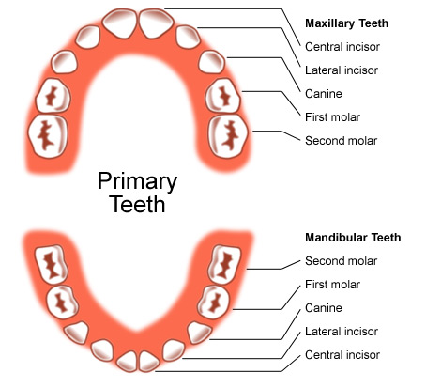

Some facts to consider
- Generally, tooth eruption occurs earlier for girls than for boys.
- Teeth erupt two by two, one on each side.
- Primary teeth are smaller and whiter than permanent teeth.
- Around the ages of two to three years old, primary teeth should all have erupted.

Signs and symptoms
There are signs and symptoms that can help recognize the eruption of teeth for babies:
- Irritation of the mouth.
- The baby placing objects or fingers in the mouth and biting on them.
- An increase of saliva in the mouth.
- Loss of appetite.
- Inflamed gums.
- General agitation.
- Redness on the cheek near the area where a tooth is erupting.
The tooth eruption process should not cause fever, vomiting, or diarrhoea. If these problems appear, it is important to consult a doctor.
To relieve the pain during tooth eruption:
- Use a clean finger to massage the gum.
- Use an anaesthetic cream sold in pharmacies (such as Orajel).
- Allow the baby to suck on a clean cloth moistened with cold water.

Permanent teeth
The following table shows when the permanent teeth (adult teeth) erupt.
Permanent Teeth
Upper Teeth | Eruption Time
Central Incisor | 7 to 8 years old
Lateral Incisor | 8 to 9 years old
Cuspid (Canine) | 11 to 12 years old
First Bicuspid (Premolar) | 10 to 11 years old
Second Bicuspid (Premolar) | 10 to 12 years old
First Molar | 6 to 7 years old
Second Molar | 12 to 13 years old
Third Molar (Wisdom Tooth) | 17 to 21 years old
Lower Teeth | Eruption Time
Central Incisor | 6 to 7 years old
Lateral Incisor | 7 to 8 years old
Cuspid (Canine) | 9 to 10 years old
First Bicuspid (Premolar) | 10 to 12 years old
Second Bicuspid (Premolar) | 11 to 12 years old
First Molar | 6 to 7 years old
Second Molar | 11 to 13 years old
Third Molar (Wisdom Tooth) | 17 to 21 years old

